Do not capitalize your short-paper title

###### A. B. Lastname1*, C. Lastname2,3, …, and F. Lastname3

1 Department of Example Science, Example University, City, Country

2 Example Labs, City, Country

3 Company, City, Country

* Corresponding author, email: [author@example.edu](mailto:author@example.edu)

Abstract

Please do not use more than 200 words. Please do not alter the formatting and style layouts which have been set up in this template document.

Keywords: Please provide three to five keywords. These keywords will be used for indexing purpose.

© 2021 Corresponding Author; licensee Infinite Science Publishing

This is an *Open Access article distributed under the terms of the Creative Commons Attribution License (http://creativecommons.org/licenses/by/4.0), which permits unrestricted use, distribution, and reproduction in any medium, provided the original work is properly cited.*

# 1. Introduction

It is expected that authors will submit carefully written and proofread material of the full paper. Spelling and grammatical errors, as well as language usage problems, are not acceptable in the final submission.

References must be listed at the end of the paper. Indicate references by [1] and [2, 3] in the text.

## 1.1. Subsection

The template is used to format your paper and style the text. All margins, column widths, line spaces, and text fonts are prescribed; please do not alter them. Do not squeeze more text into the limited number of pages. Use only the formats defined for this document.

Number equations consecutively with equation numbers inparentheses flush with the right margin, as in (1). Use parenthesesto avoid ambiguities in denominators. Punctuate equationswhen they are part of a sentence, as in

$a^{2}+b^{2}=c^{2}$ (1)

You may use full color images. Make sure figures are legible. The digital versions of your paper will be in full color. Fig. 1 is an example for a figure.

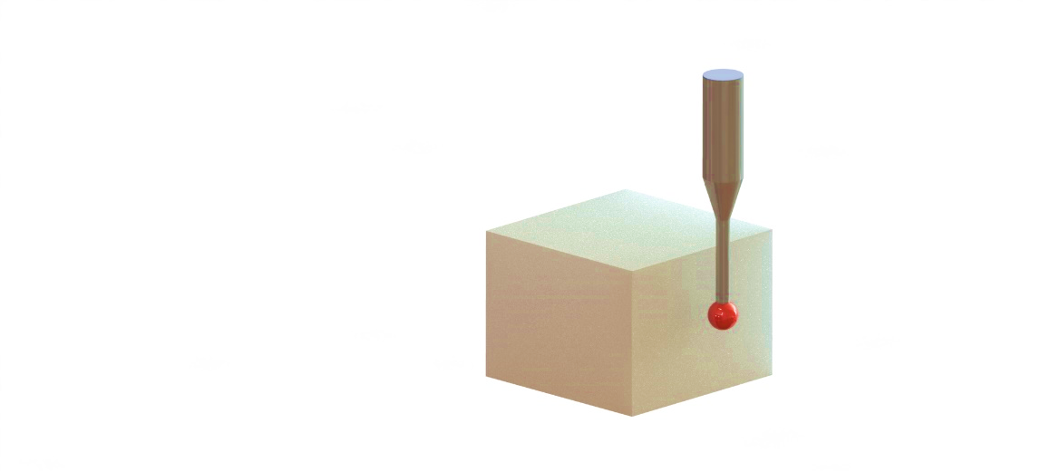

**Fig 1.** It is good practice to explain the significance of the figure in the caption. Each figure should be able to be standing alone. You may use full color images.

Do not put borders around your figures. Each figure/table should be mentioned in the text.

Use the abbreviation “Fig.” throughout the text even at the beginning of a sentence.

## 1.2. Second subsection, if necessary

Do not abbreviate “Table”. Tables are numbered with Arabic numerals, as can be seen in Table 1.

# 2. Material and methods

All materials and methods that have been used in the work must be clearly stated and described in sufficient details or with references.

Define abbreviations and acronyms the first time they are used in the text, even after they have been defined in the abstract. Do not use abbreviations in the title or heads unless they are unavoidable.

**Table 1**. Font size and format.

|  |  |  |
| --- | --- | --- |
| **Format Style** | **Font Size and Type** | **Element** |
| Title | 18, Bold, Cambria | Title |
| Author List | 11, Bold, Cambria | Authors |
| Affiliations | 9, Italic, Cambria | Affiliation |
| Corr. Author’s E-Mail Address | 9, Italic, Cambria | Affiliation |
| Abstract | 12, Bold, Cambria | Abstract |
| Abstract text | 9, Cambria | Abstract text |
| Keywords | 9, Cambria | Keywords |
| Keywords text | 9, Cambria | Keywords text |
| Section Title | 14, Bold, Cambria | Section Title |
| Subsection Title | 12, Italic, Cambria | Subsection Title |
| Text | 10, Cambria | Normal |
| Figure Caption | 9, Cambria | Caption |
| Table Caption | 9, Cambria | Caption |
| Acknowledgment Title | 10, Bold, Cambria, | Acknowledg-ments |
| Acknowledgment Textblock | 9, Cambria | Acknowledg-ment Textblock |
| Author’s Statement Title | 10, Bold, Cambria, | Acknowledg-ments |
| Author’s Statement Textblock | 9, Cambria | Acknowledg-ment Textblock |
| Reference Title | 10, Bold, Cambria | References |
| Reference Textblock | 9, Cambria | Reference Style |

# 3. Results and discussion

The results of the work should be explicitly described and illustrated. Supporting figures, tables and images of the results may be included in the full paper. Figures, tables, and equations must be inserted in the text and may not be grouped at the end of the paper.

# 4. Conclusions

Conclusions should include the most important findings inferred from the results, and the future works and recommendations. Although a conclusion may review the main points of the paper, do not replicate the abstract as the conclusion. A conclusion might elaborate on the importance of the work or suggest applications and extensions.

### Acknowledgments

##### Sponsor and financial support acknowledgments are placed here. Use the singular heading even if you have many acknowledgments.

### Author’s statement (Do not remove this paragraph – please check which statements are applicable)

##### Conflict of interest: Authors state no conflict of interest. Informed consent: Informed consent has been obtained from all individuals included in this study. Ethical approval: The research related to human use complies with all the relevant national regulations, institutional policies and was performed in accordance with the tenets of the Helsinki Declaration, and has been approved by the authors’ institutional review board or equivalent committee.

#### References

1. Kaynak, Y. and O. Kitay, *The effect of post-processing operations on surface characterisics of 316L stainless steel produced by selective laser melting.* Additive Manufacturing, 2019. **26**: p. 84-93.

2. Koc, B., Y. Ma, and Y.S. Lee, *Smoothing STL files by Max‐Fit biarc curves for rapid prototyping*. Rapid Prototyping Journal, 2000. **6**(3): p. 186-205

3. Kucukgul, C., et al., *3D bioprinting of biomimetic aortic vascular constructs with self‐supporting cells.* Biotechnology and bioengineering, 2015. **112**(4): p. 811-821.